software costs

software engineering & computer science

software engineering & system engineering

software process

software process model

cost of software engineering

CASE (Computer-Aided Software Engineering)

**software costs**

- dominate computer system cost

- software costs more to maintain than it does to develop

- software engineering is concerned with cost-effective software development

**software engineering & computer science**

- computer science is concerned with theory and fundamentals

- software engineering is concerned with the practicalities of developing and delivering useful software

**software engineering & system engineering**

- system engineering is concerned with all aspects of computer-based systems development including hardware,software and process engineering.

- software engineering is part of this process concerned with developing the software infrastructure,control applications and databases in the system.

**software process**

- Generic activities in all software processes are:

软件描述 • Specification - what the system should do and its development constraints

软件设计和实现 • Development - production of the software system

软件有效性验证 • Validation - checking that the software is what the customer wants

软件进化 • Evolution - changing the software in response to changing demands.

**software process model**

- Examples of software process model are:

• Workflow model - sequence of activities;

• Data-flow model - information flow (transformation carried out by people);

• Role/action model - who does what (roles of people involved in the software process and the activities for which they are responsible).

- Generic models of software development

瀑布模型 • Waterfall approach (represent activities as separate process phases)

增量式开发 • Iterative development (abstract to concret system)

面向复用的软件工程• Component-based software approach (parts of the system already exist).

**cost of software engineering**

- Roughly 60% of costs are development costs, 40% are testing costs. For custom software, evolution costs often exceed development costs.

- Costs vary depending on the type of system being developed and the requirements of system attributes such as performance and system reliability.

- Distribution of costs depends on the development model that is used.

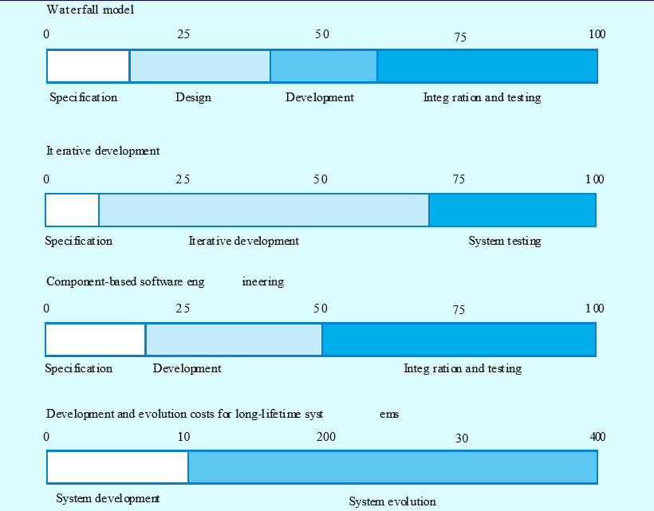

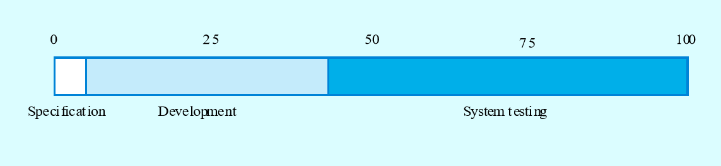

**CASE (Computer-Aided Software Engineering)**

Software systems that are intended to provide automated support for software process activities.

CASE systems are often used for method support.

Upper-CASE

• Tools to support the early process activities of requirements and design;

Lower-CASE

• Tools to support later activities such as programming, debugging and testing.